# ZOMATO SQL ANALYSIS

1. **Total Amount spent by each customer**

* select sales.userid,sum(product.price) as Total_spent from sales

join product on sales.product_id = product.product_id group by sales.userid order by sales.userid

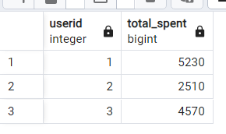

1. **How many days each customer visited zomato**

* select userid,count(distinct created_date) as visits from sales group by userid

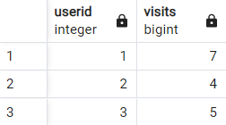

1. **First Product purchased by each customer**

* with rankers as (select *,rank() over (partition by userid order by created_date) as pos from sales) select * from rankers where pos =1

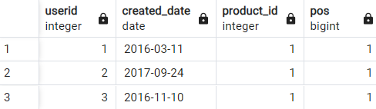

1. **Most purchased item in the menu and how many times that item purchased by all customer**

* select product_id from sales group by product_id order by count(product_id) desc limit 1

(from this we get the most purchased item)

* select userid,count(product_id) from sales where product_id = 2 group by userid

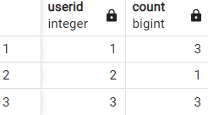

1. **Most popular item for each customer**

* with rnt as(select *,rank() over (partition by userid order by product_total desc) as en from (select userid,product_id,count(product_id) as product_total from sales group by 1,2 order by userid)) select * from rnt where en = 1

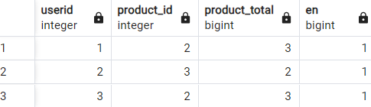

1. **first item purcchased by cudtomer after become member on zomato**

* with aas as(select *,rank() over (partition by sales.userid order by created_date) as rnk from sales join goldusers_signup on goldusers_signup.userid = sales.userid where created_date > gold_signup_date) select * from aas where rnk = 1

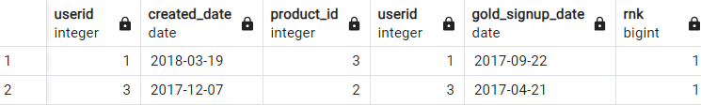

**7.item purchased by customer just befome become member**

* with aas as(select *,rank() over (partition by sales.userid order by created_date) as rnk from sales join goldusers_signup on goldusers_signup.userid = sales.userid where created_date < gold_signup_date) select * from aas where rnk = 1

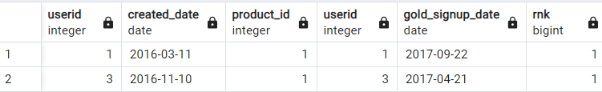

**8.total orders and amount spent of each customer befome become member**

* select s.userid,sum(p.price),count(s.product_id) from sales as s join product as p on s.product_id = p.product_id join goldusers_signup as g on s.userid=g.userid where created_date < gold_signup_date group by s.userid order by sum(p.price)

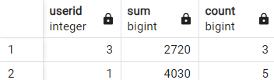

**9.points for amount diff for each product**

* select dd.userid,sum(dd.Reddem_Coins) from (select tr.*,rnt/Points as Reddem_Coins from (select tt.*, case when product_id = 1 then 5 when product_id = 2 then 2 when product_id = 3 then 5 else 0 end as Points from (select p.product_id,s.userid,sum(p.price) rnt from sales as s join product as p on s.product_id = p.product_id group by 2,1 order by sum(p.price),s.userid) as tt) as tr ) as dd group by dd.userid

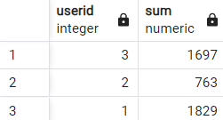

**10.total points in one year after the gold membership join and the points is 5 for every 10rs purchase on every product**

* select *,dd.cost*0.5 as total_points_in_1Year from (select s.userid,s.product_id ,s.created_date,g.gold_signup_date,p.price as cost from sales s join goldusers_signup g on g.userid = s.userid join product p on s.product_id=p.product_id where created_date >= gold_signup_date and created_date <= gold_signup_date + interval '1 year') as dd

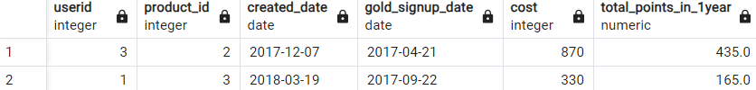

**11.rank all transaction of customer**

* select *,rank() over(partition by userid order by created_date) as tra_rank from sales order by userid

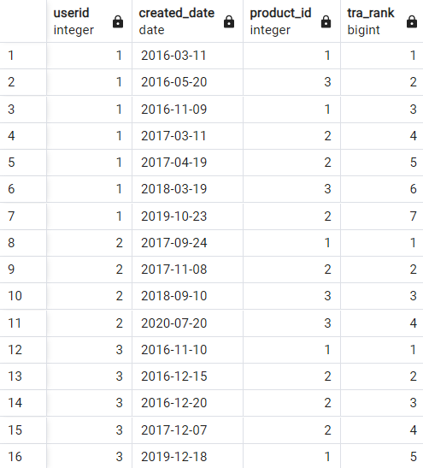

**12.rank only members transaction**

* (select dd.*, case when gold_signup_date is null then 0 else dense_rank() over(partition by User order by gold_signup_date)end as rnk from (select s.userid as User,s.created_date,s.product_id,g.gold_signup_date from sales s left join goldusers_signup g on g.userid = s.userid and created_date >= gold_signup_date) as dd )

